**Name:- Dharan Gowda Superset id:-6387532**

**Create a React Application named “officespacerentalapp” which uses React JSX to create elements, attributes and renders DOM to display the page.**

**Create an element to display the heading of the page.**

**Attribute to display the image of the office space**

**Create an object of office to display the details like Name, Rent and Address.**

**Create a list of Object and loop through the office space item to display more data.**

**To apply Css, Display the color of the Rent in Red if it’s below 60000 and in Green if it’s above 60000.**

**Step 1: Create App(officespacerentalapp):-  
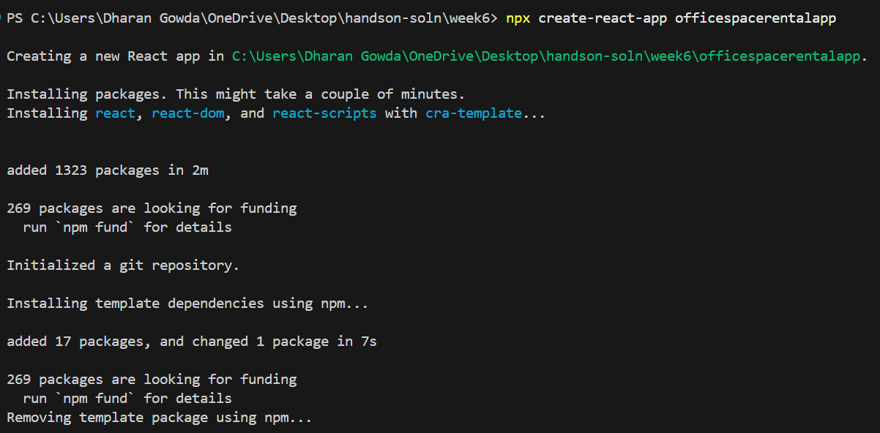**

**Step 2: codeing App.js with the following code**

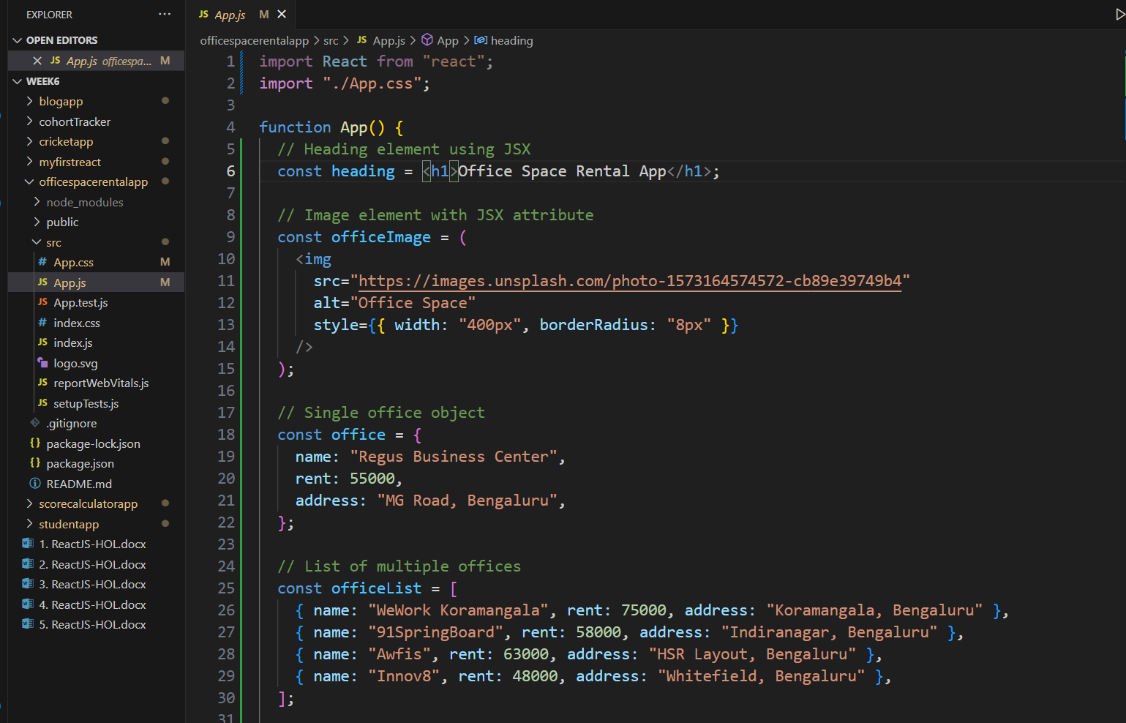

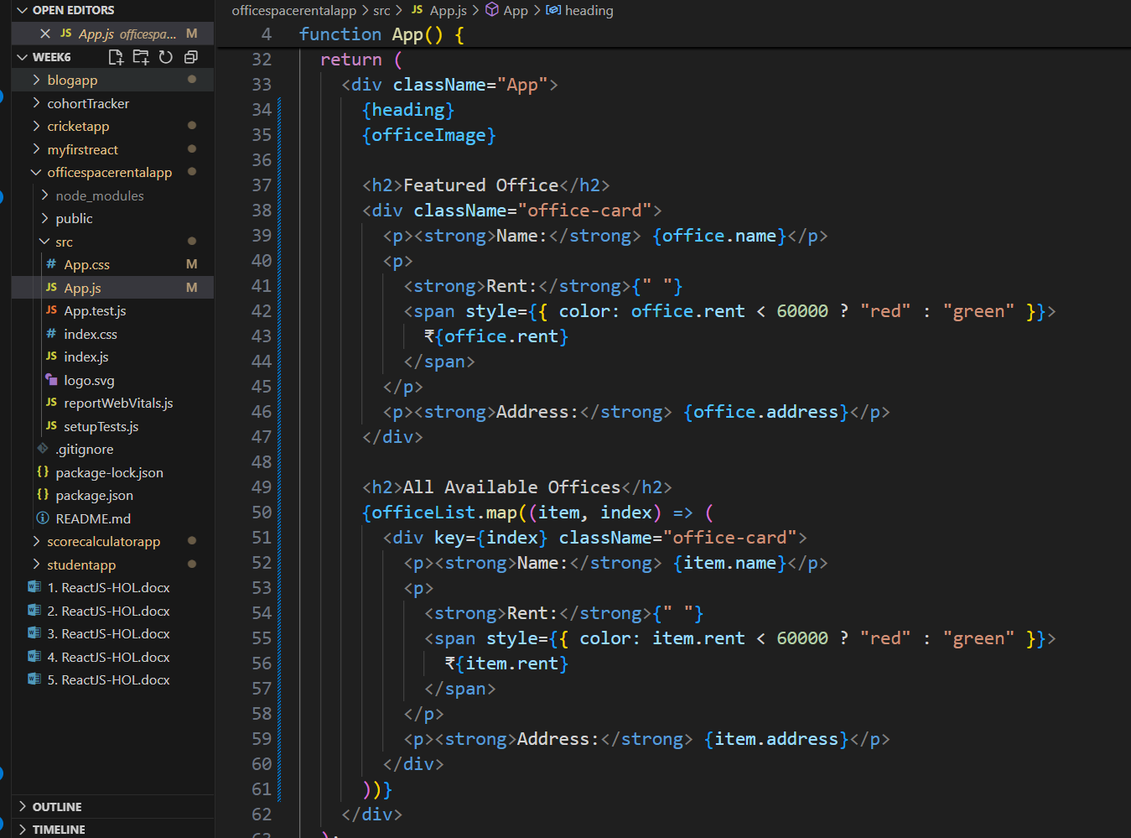

**Step 3:Code App.css with the required styling**

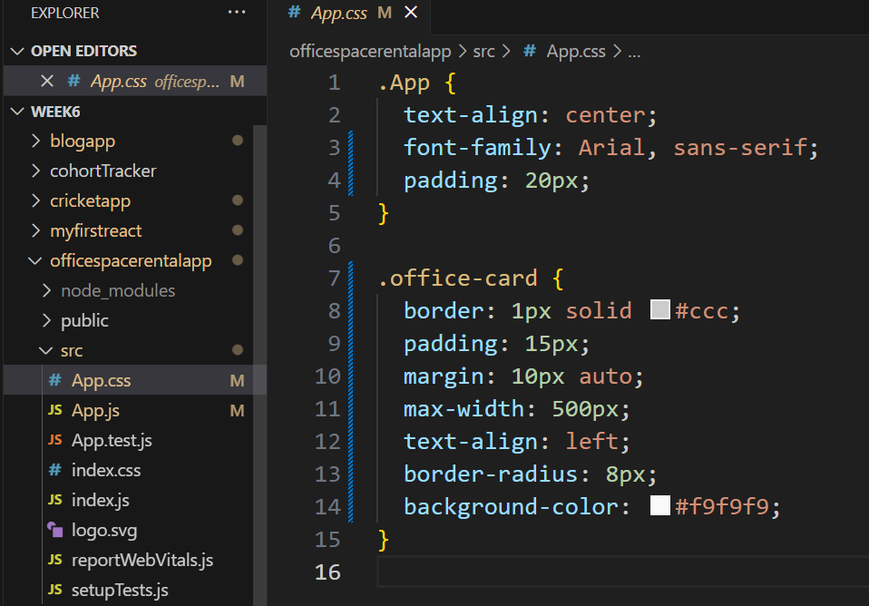

**OUTPUT:-**

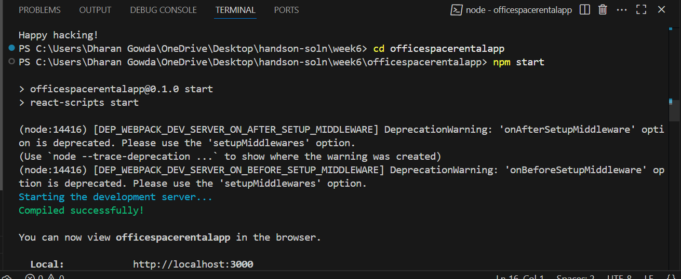

**OUTPUT IN BROWSER:-**

